Public Roadwork Employees and NAICS Coding
Will Mayer September 2, 2025
Bottom Line Up Front: In total, 967 records in Contracts use SIC 9621. 909 of these use Trade PSD001, and the rest mostly cover public transportation authorities. 808 of 909 PSD001 records are “easy matches” which we can identify as covering public road maintenance employees. These records should be moved to NAICS 237310 for easier querying. 42 of the remaining 101 records that are not “easy matches” (SIC 9621, Trade PSD001, not picked up by keywords) are contracts covering port and airport authorities, and should be excluded. The remaining 59 records in this bucket (SIC 9621, Trade PSD001, not picked up by keywords) are “wider” contracts that are more challenging to classify.
Our procedure so far: Classify public works department (PWD) contracts based on their primary function and use Trade = PSD001.
- SIC Code 9621 for contracts primarily covering road work.
- SIC Code 9631 for contracts primarily covering any other work (water, sewer, electricity, communications, etc.)
How are PWD Contracts Classified?
967 records in the contract database use SIC 9621. 808 of these are “easy matches,” where one of the following keywords are explicitly referenced in the employer, employer division, or JobsSOC fields: [“public work”, “road”, “street”, “highway”]
- 792 of these 808 “easy matches” explicitly reference road/highway work in the employer, employer division, or JobsSOC fields. See Figure III.
Easy Match? | Record Count | Sum Unit Size
Easy Match | 808 | 8,383
Not Picked Up by Keyword Heuristics | 159 | 9,938

- NumMembers from Contracts, instead of ActiveCount from TITAN, is used to estimate unit sizes. Although measures from Contracts are less accurate than measures from TITAN, inconsistency in how locals request TITAN numbers for city government employers make TITAN estimates unreliable. See Remaining Questions #4.
Review of SIC 9621 Records Excluding “Easy Matches”
Excluding “easy matches,” 159 records in Contract use SIC 9621. Of these records, 101 are classified in Trade Division PSD001 (State/County/Local/Regional Authorities,) and 56 are classified in PSD007 (Public Transportation.)
Trade | Count | Sum Unit Size
PSD001: State/County/Local/Regional Authorities | 101 | 7,478
PSD007: Public Transportation | 56 | 2,171
PSD008: Non-profit / Professional Services | 1 | 282
PSD003: Schools | 1 | 7
Review of Remaining Records with SIC 9621 and PSD007 Trade Division
Next, I examine the following 56 records to determine whether records with SIC 9621 and Trade PSD007 are correctly classified and should be excluded from public road maintenance queries:
- Record not picked up by “easy matches” query (e.g., does not explicitly reference PWD-related keywords in employer division, remarks, or JobsSOC)
- SIC = 9621
- And Trade Division = PSD007 (Public Transportation)
These records are correctly classified as Public Transportation, i.e., they should be excluded from queries that search for contracts covering public road maintenance. Some illustrative examples:
Employer | Description and Employees Covered | Covers Public Road Maintenance?
Madison, Wisconsin Transportation Department | Mass transit operators and office employees. Covers bus cleaners and mechanics, receptionists, and accountants. | No
Southeastern Pennsylvania Transportation Authority | Covers scheduling and receiving clerks and transit dispatchers. | No
L.A. County Metro Transportation Authority | Covers security officers, security dispatchers, and canine officers. | No
Port Authority of New York and New Jersey | Covers port authority security officers. | No
The following evidence further suggests that the combination of SIC 9621 and Trade PSD007 where no explicitly PWD-related keywords exist indicates that a record does not cover public road maintenance.
- None of these records reference SOC code 47-4051: Highway Maintenance Workers.
- 54 of 56 these records explicitly reference “transit,” “transportation,” or “bus” in the employer, employer division, or remarks fields.
  - The only two records that do not reference these keywords are port authority contracts—not road maintenance.
Records using SIC 9621 and Trade PSD007 should therefore be excluded from queries searching for contracts covering public road maintenance.

Review of Remaining Records with SIC 9621 and PSD001 Trade Division
Next, I move to the following 101 records to determine whether records with SIC 9621 and Trade PSD001, excluding “easy matches,” should be included in queries of public road maintenance records:
- Record not picked up by “easy matches” query (e.g., does not explicitly reference PWD-related keywords in employer division, remarks, or JobsSOC)
- SIC = 9621
- And Trade Division = PSD001 (State, County, and Local Authorities)
Many of these records represent “wide” contracts, which cover a variety of different types of employees and are difficult to classify. However, some large buckets can be picked out: airport and port authorities, and state turnpike/highway commissions. See Figure IV for a full breakdown of this bucket.
Employer Bucket | Record Count | Covers Public Road Maintenance?
Airport and Port Authorities | 42 | No
State Turnpike/Highway Commissions | 17 | Yes, but most contracts are wide and cover more than just road maintenance
Other | 42 | It depends
42 of 101 records represent either port or airport authorities and should be excluded from queries searching for public roadwork maintenance contracts.
17 of 101 records represent turnpike/highway/thruway authorities and commissions. Many but not all these records are “wide” contracts. These should be included in queries searching for public road maintenance contracts, as they cover city/state workers maintaining highways, but it’s uncertain how many employees work on road maintenance specifically (as opposed to painting signs or staffing toll booths.) Some illustrative examples:
Employer | Description and Employees Covered | Covers Public Road Maintenance?
New York State Thruway Authority | Covers 2100 employees. Covers thruway maintenance, clerical employees, toll collectors, and radio dispatchers. | Yes, but not all employees
Pennsylvania Turnpike Commission | Covers inventory clerks, facilities maintenance, toll collectors, and highway construction employees. | Yes, but not all employees
Ohio Turnpike and Infrastructure Commission | Covers trade construction, auto mechanics, stores and maintenance clerks | Yes, but not all employees
Golden Gate Bridge, Highway, and Transportation District | Split into three agreements—not one wide contract. One covers bus transit, one covers ferry operations, one covers lane construction. | Yes, and only under one agreement (bridge division)
The “others” bucket contains the remaining 42 records that don’t fall neatly into port/airport authorities or highway/turnpike authorities. These tend to be the widest contracts and are the most difficult to classify. Some illustrative examples:
Employer | Description and Employees Covered | Covers Public Road Maintenance
Shawnee (County of), Kansas, Board of Commissioners | Covers clerical, corrections, health agency, parks, and public works. | Yes, but incredibly wide contract
State of Illinois; many different departments | Covers depts. of central management services, corrections, state police, transportation. | Yes, but incredibly wide contract
State of Montana, Transportation Department | Covers facilities maintenance, custodians, auto maintenance employees, lane striping, highway sign painting. | Yes, but incredibly wide contract (excavating/crack sealing, etc. covered under maintenance employees)
Mahoning (County of), Ohio, County Engineer’s Office | Covers auto mechanics, sign painters, construction, lane striping, etc. | Yes, but incredibly wide contract
Philadelphia Parking Authority | Covers maintenance, cashiers, etc. at Philadelphia airport parking garage. | No
Montgomery (County of), Ohio, Engineer Department | Covers highway maintenance employees. | Yes, exclusively
Review of SIC 237310 Records
Finally, I investigate how NAICS 237310 (Highway, street, and bridge construction) has been used to determine whether it is a feasible solution to reclassify PWD contracts that cover public road maintenance.
853 records in total use NAICS 237310, with 847 classified under different Construction trade divisions. Only 5 contracts use PSD001, all of which cover road maintenance employees.
The bucket created by the combination of NAICS 237310 and Trade PSD001 is a suitable group to classify these records.
Recommendation
PWD contracts should be assigned to the NAICS corresponding to the primary construction trade associated with the employees covered by the contract, with Trade PSD001. To start, contracts covering road maintenance should be classified with NAICS 237310.
This solution makes it easier to query PWD contracts covering public road maintenance. The bucket (NAICS 237310, Trade PSD001) currently only holds 5 records, all of which cover road maintenance employees. This bucket can exclude the contracts currently under SIC 9621 with Trade PSD001 that should not be included in searches for contracts covering public road maintenance, like airports, ports, and parking authorities.
To find all PWD-related contracts, a query could search for all the NAICS codes representing construction trades performed by city/local authorities with Trade PSD001. This solution would also enable more granular search among different types of PWD contracts (i.e., how many PWD contracts specifically cover road maintenance vs. sewer work, etc.)
Remaining Questions
- The largest question left unsolved by this solution is how to handle different types of “wide” contracts. Although this solution allows for more granular searching, it invites ambiguity for contracts where there is not a clear “primary” function of the employees covered. For example:
  - Contracts covering multiple types of public works-related construction trades (i.e., contracts covering street and sewer departments, contracts covering sewer and electric lines, contracts covering the entire public works department.)
  - Contracts covering the public works department and other public employees (i.e., highway commissions covering highway maintenance and toll collectors, large city contracts covering all city employees, etc.)
  - In my research, I have encountered various combinations of public employees covered including the above and more.
  - Using the NAICS 2 field could help in some scenarios, but many contracts cover more than two construction trades performed by public employees.
- How should state highway/turnpike commissions be classified? These contracts cover many represented employees performing a wide range of job functions. Many of these contracts cover highway maintenance, sign painting, toll collection, and white-collar transportation administration.
- For PWD contracts not covering road maintenance, how are the other NAICS-Trade PSD001 buckets currently used. Are they nearly empty like NAICS 237310 is? For example:
  - For sewer maintenance, is the bucket (NAICS 221320, Trade PSD001) empty?
  - For park groundskeeping, is the bucket (NAICS 561730, Trade PSD001) empty?
- Locals vary in how they request TITAN numbers representing public city employers. This complicates our use of ActiveCount from TITAN to estimate the number of employees represented in these trades. For example, some locals request a different TITAN number for different departments within a city government, while others request one TITAN number for the entire city government. Because requesting TITAN numbers is up to the local union, it is difficult to differentiate how TITAN numbers are used throughout the country This problem might not be solvable on our side without a larger undertaking.
  - For example, the City of Chicago is reported under one TITAN number and reports 1762 Active Members in TITAN. However, some contracts for specific units within the city government report only 2-8 members in Contracts, leading to a disparity of 1,754 members.
  - Most disparities are clustered in the 1-499 range, with 174 values exactly matching.

Disparity Sizes (TITAN ActiveCount – Contracts NumMembers)
- All TITAN employers where Trade = PSD001 and “city” in Company name
Disparity Size | Minimum Disparity in Bucket | Number of Records in Bucket
-400 to -199 (Contracts value larger than TITAN) | -378 | 3
-200 to -1 (Contracts value larger than TITAN) | -127 | 373
Exactly 0 (same values) | 0 | 174
1 to 499 | 1 | 630
500 to 999 | 506 | 10
1,000 to 1,499 | n/a | 0
1,,500 to 2000 | 1,737 | 3
2,000+ | n/a | 49
Sample Decision Tree
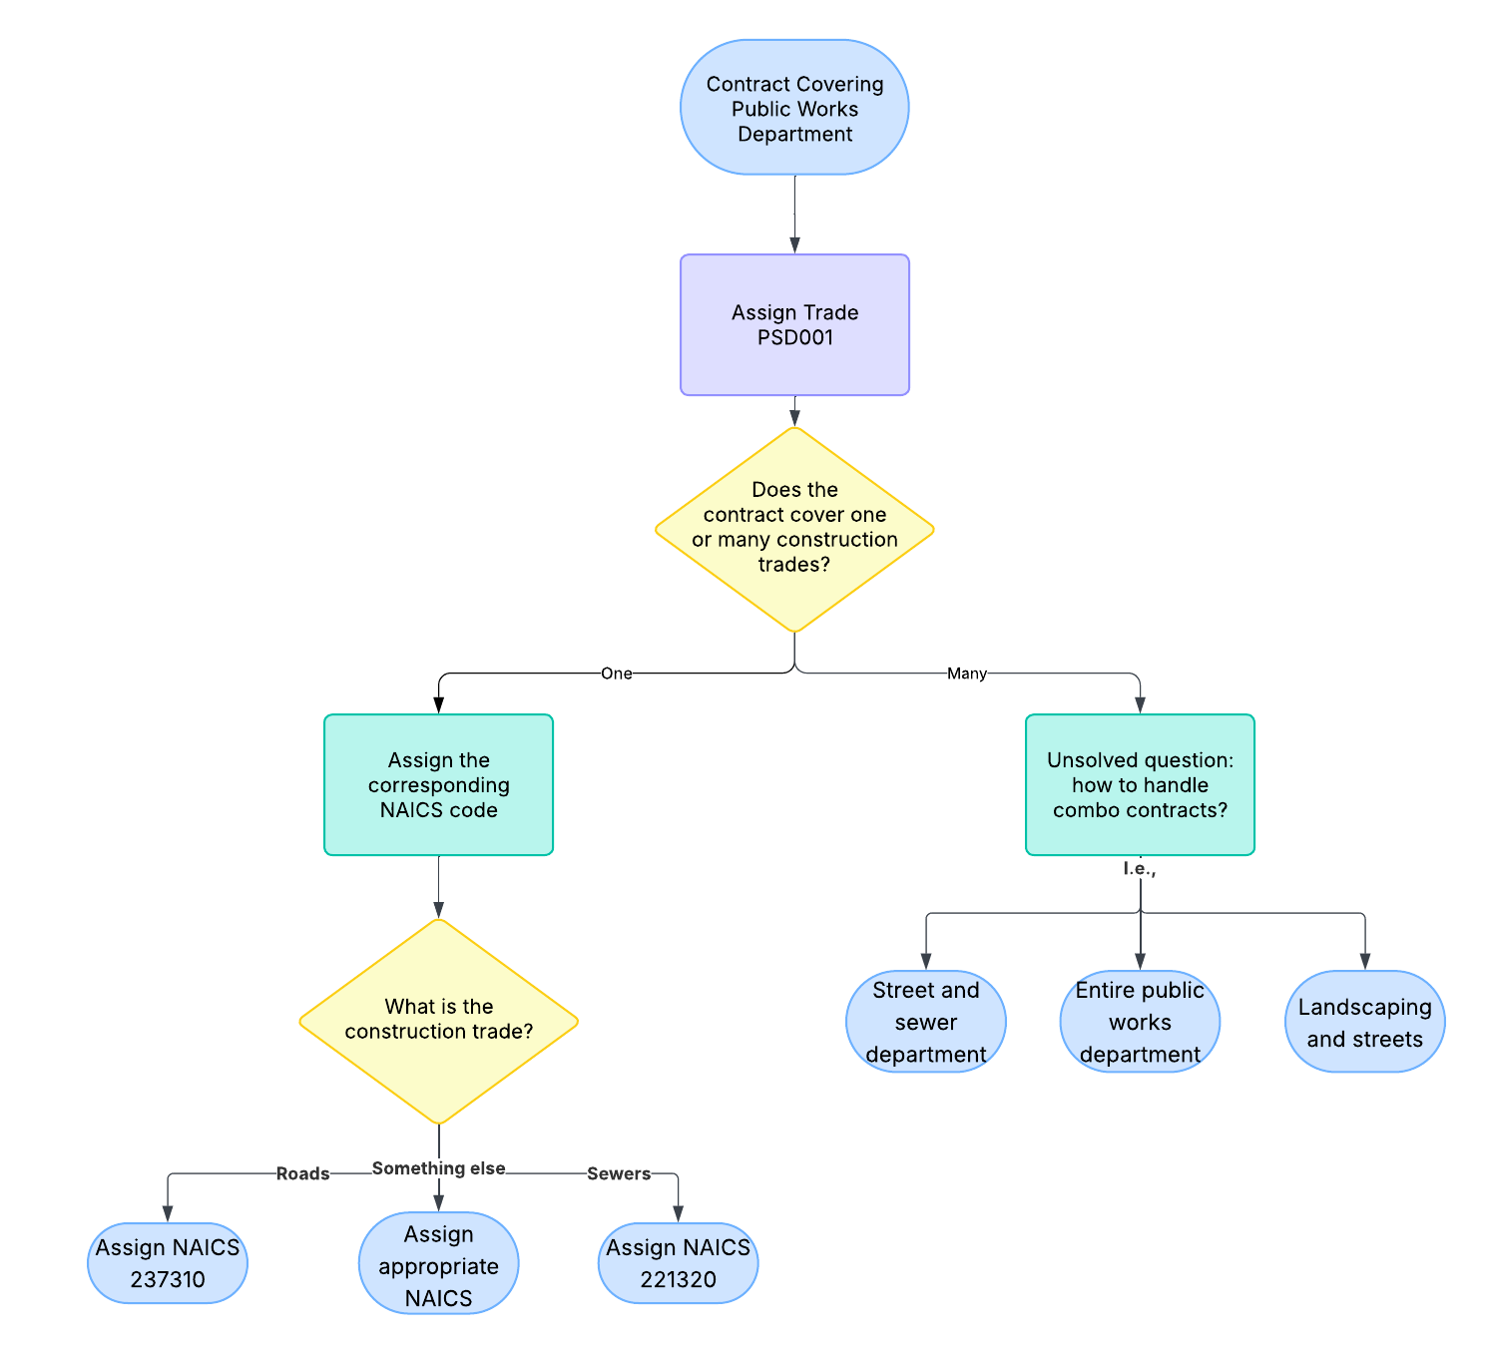
Sample Querying for PWD Contracts
- To find a specific construction trade: select where NAICS = the construction trade and Trade = PSD001
  - I.e., Select where NAICS = 237310 and Trade = PSD001 public road maintenance
  - Select where NAICS = 221320 and Trade = PSD001 public sewer maintenance
- To find all public works contracts: maintain a list of construction trades associated with city maintenance, select where NAICS = any of those and Trade = PSD001
  - I.e., Select where NAICS = 237310 or 221320, etc., and Trade = PSD001
  - A non-exhaustive list of codes we could consider using:
    - 237310: Highway, Street, and Bridge Construction
    - 221320: Sewage Treatment Facilities
    - 561730: Landscaping Services
    - 238210: Electrical Contractors (streetlights, traffic signals)
    - 238220: Plumbing, Heating, and Air Conditioning Contractors (pipefitting, HVAC in municipal buildings)
    - 236220: Commercial and Institutional Building Construction (carpentry in municipal buildings)
    - 238140: Masonry Contractors (sidewalks, curbs, retaining walls)
    - 238990: Other Specialty Trade Contracts (general maintenance and repair)
  - Alternatively, use prefixes for more broad coverage with the risk of introducing noise
    - I.e., Select where NAICS LIKE “237*” (heavy construction) OR “238*” (building construction), etc.
  - A mix of prefixes (237 and 238) with more specific targets added could be a strong approach.
Takeaways
- Of 901 records with SIC 9621 and Trade PSD001, ~800 records are “easy matches” which we can confidently identify as covering public road maintenance employees.
  - The most common employers that are outliers in this group are port authorities and airports.
  - Turnpike/highway authorities are “wide” contracts that are difficult to disentangle.
- Moving forward, projects like these could be viable candidates for machine learning tasks.
  - Now that I’ve done the legwork of confidently classifying ~800 records as primarily covering public road maintenance, supervised classification algorithms could use features like the jobs covered, entered remarks, trade division, and the employer/division names to estimate the probability that a given contract covers public road maintenance employees.
    - E.g., given a random record, how do these features impact the probability that it covers public road maintenance employees?
  - These types of solutions avoid the costly computation of transforming entire full-text contracts by leveraging the information extracted by DRS in the Contract database.
  - A model like logistic regression, decision tree, or random forest could fit these projects in the future to provide a gut-check “first guess” where the following conditions are met:
    - Features like jobs covered, employer name and division, and remarks are consistently entered.
    - DRS has done the legwork to flag records as confidently representing the target outcome (e.g. covers public road maintenance.)
Appendix I: Is SIC 9621 used to identify PWD Contracts?
The following section takes a detour to confirm our assumption that SIC 9621 has been consistently used to classify PWD contracts primarily covering public road maintenance.
To get a picture of how PWD contracts are currently classified in the database, I identify “easy matches” where the employer is a local (city/town/county/state) government, and keywords “public works,” “road,” “street,” or “highway” are explicitly used in the employer division or covered jobs fields.
These keyword heuristics captured a sample of 1,998 records of PWD contracts. Of the selected records, all but nine are classified with the “State, county, and local services” trade division, PSD001 (Figure I.)
Next, I excluded the nine records not classified with trade division PSD001 and examined the breakdown of SIC codes associated with the remaining records. Most records in this sample use either SIC Code 9621 or 9631, tracking with our assumptions about the department’s procedure thus far. The third most common SIC code in this sample is 9100, a placeholder that I assume stands for “Public administration, unclassified” (Figure II.)
Finally, to confirm that SIC 9621 records correspond to road maintenance employees, I examine the prevalence of explicit references to road-related keywords among this sample of “easy matches” with SIC 9621. Among “easy matches” with SIC 9621, all but 10 explicitly reference roadwork either in the employer division field or in the employees covered field. The remaining 10 explicitly reference public works, but not road maintenance. In other words, of the records we can confidently assume represent PWD contracts, contracts primarily covering public roadwork use SIC 9621 (Figure III.)
Figures and Crosstabs
Figure I: How many contracts cover PWDs?
Bottom line: The overwhelming majority of PWD contracts are correctly classified in Trade PSD001.
- Methodology: Identify PWDs by matching public works-related keywords.
- Constraints:
  - “Public work,” “road,” “highway,” “street,” “highway” in employer division and/or remarks field OR “highway” in JobsSOC (targeting 47-4051: Highway Maintenance Workers) AND
  - “City,” “County,” “Town,” “State,” “Village” in employer OR trade = PSD001
Figure I Crosstab: Are PWDs correctly classified with PSD001?
- This table reflects the different trade divisions used by records with PWD-related keywords that cover local public employees.
Trade | Record Count | Sum Unit Size
PSD001: State, County, Local | 1,979 | 31,050
BMT008: General Construction | 4 | 24
SWR001: Solid Waste and Recycling | 2 | 300
K06? | 1 | 6
PSD000: presumably, public services undefined | 1 | 2
BMT001: Heavy-highway construction | 1 | null
Figure II: What SIC Codes do PWD Contracts Use?
Bottom line: Most PWD contracts use SIC codes 9100, 9621, or 9631.
- Methodology: Because nearly all the above results have Trade = PSD001, investigate only records classified with PSD001.
- Constraints: All records from First Query where Trade = PSD001.
Figure II Crosstab
- This table reflects breakdown of SIC codes used to record contracts with public local employees working on public works and roads.
SIC Code | Record Count | Unit Size
9631: REGULATION, ADMINISTRATION OF UTILITIES | 802 | 12,955
9621: REGULATION, ADMIN. OF TRANSPORTATION | 799 | 8,333
9100: GENERAL GOVERNMENT | 353 | 9,103
9511: AIR, WATER AND SOLID WASTE MANAGEMENT | 23 | 539
9221: POLICE PROTECTION | 14 | 124
9512: LAND, MINERAL, WILDLIFE AND FOREST CONSERVATION | 4 | 94
9311: FINANCE, TAXATION AND MONETARY POLICY | 1 | 16
9223: CORRECTIONAL INSTITUTIONS | 1 | 8
9121: LEGISLATIVE BODIES | 1 | 5
9111: EXECUTIVE OFFICES | 1 | 64
4581: AIRPORTS, FLYING FIELDS AND SERVICES | 1 | 13
null | 1 | 107

Figure III: How many “Easy Matches” are Explicitly Road Related?
Bottom line: We can confidently estimate that almost all the selected records are PWD contracts covering primarily road maintenance.
- Methodology: Use road-related keywords to identify records we can confidently estimate as covering road maintenance employees.
- Constraints: All records from Second Query where SIC Code = 9621.
Figure III Crosstab
- I collapse records from the sample to understand how many “easy matches” with SIC 9621 explicitly reference public roadwork.
  - “Road Keyword in Division” à “road” / “highway” / or “street” in division field
  - “Road Keyword in JobsSOC” à “highway” in JobsSOC (targeting 47-4051)
  - “Not Explicitly Road Related” à all other records including null/blank.
Total Road Related | Record Count | Sum Unit Size
Total Road Related | 792 | 8,272
Not Explicitly Road Related | 16 | 111

Road Related Categories | Record Count | Sum Unit Size
Road Keyword in Division | 695 | 5,790
Road Keyword in JobsSOC | 97 | 2,482
Not Explicitly Road Related | 16 | 111

Figure IV: What kinds of records use SIC 9621 and Trade PSD001 that are not “easy matches?”
- Adjustments: collapsed similar entries
Division | Count
null | 59
TRANSPORTATION DEPARTMENT (and related public transport entries) | 14
AIRPORT (and related) | 8
POLICE DEPARTMENT | 3
SUPERVISORY/PROFESSIONAL/WHITE COLLAR UNIT (and related) | 3
VEHICLE MAINTENANCE DEPARTMENT | 2
ENGINEER DEPARTMENT (and related) | 2
CENTRAL OFFICE | 1
BOARD OF COUNTY COMMISSIONERS | 1
ADMINISTRATION AND DEVELOPMENT DIV. | 1
BRIDGE DIVISION (potentially PWD) | 1
MAINTENANCE DEPARTMENT (potentially PWD) | 1
NON-SWORN SAFETY PERSONNEL UNIT | 1
PARKING AUTHORITY | 1
PARKS AND RECREATION DEPARTMENT (potentially PWD) | 1
RADIO ROOM OPERATORS | 1
SAFETY DEPARTMENT | 1

